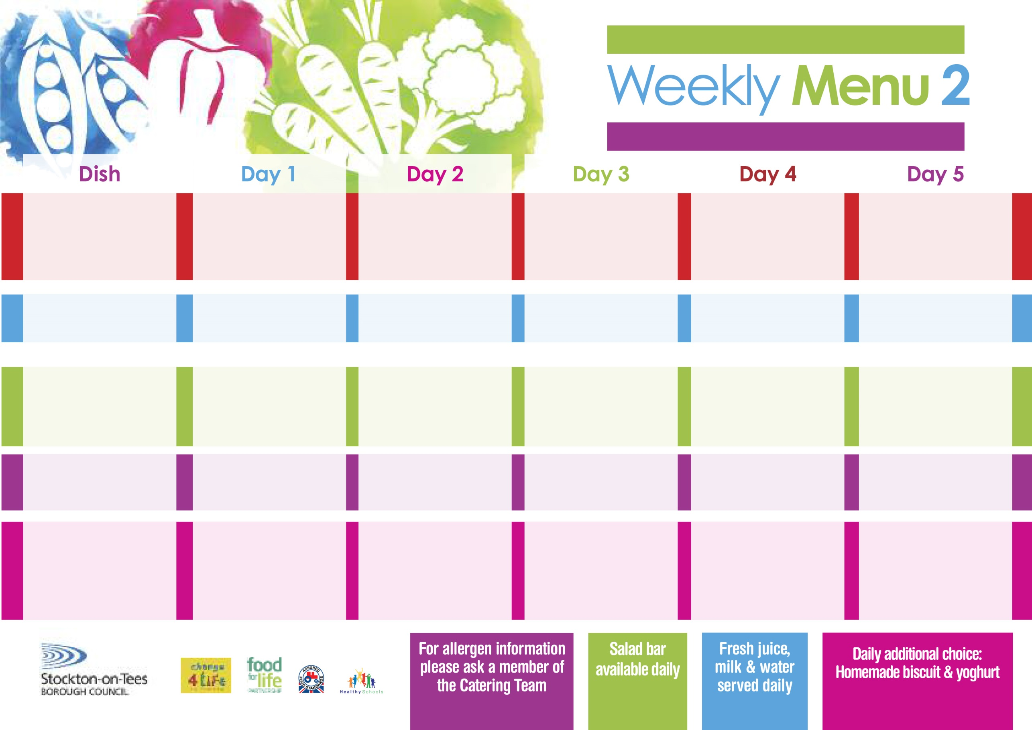

**8th January, 5th February & 11th March, 2024**

**Homemade Pizza (V)**

**Baked Potato Wedges**

**Garden Peas**

**Spaghetti Hoops**

**Macaroni Cheese (V)**

**Homemade Herby Bread**

**Garden Peas**

**Tuna Sandwich**

**Oven Roasted Potatoes**

**Chocolate Chip Sponge**

**with Custard Sauce**

**Cold Bar**

**Fresh Fruit Bowl**

**Lasagne**

**Homemade Garlic Bread**

**Tossed Salad & Coleslaw**

**Quorn Lasagne (V)**

**Jacket Potato filled with**

**Tuna, Cheese (V)**

**or Baked Beans (V)**

**Cheese Sandwich (V)**

**Baked Jacket Potatoes**

**Festival Shortcake**

**with Custard Sauce**

**Cold Bar**

**Fresh Fruit Salad**

**Sausage Rolls**

**Oven Roasted Potatoes**

**Baked Beans**

**Sweetcorn**

**Cheese Roll (V)**

**Homemade Quiche (V)**

**Egg Mayo Sandwich (V)**

**Oven Roasted Potatoes**

**Eve’s Pudding**

**with Custard Sauce**

**Cold Bar**

**Fresh Fruit Bowl**

**Fish Goujons**

**Oven Baked Chips**

**Garden Peas**

**Baked Beans**

**Cheese Omelette (V)**

**Oven Baked Chips**

**Garden Peas**

**Baked Beans**

**Tuna Sandwich**

**Oven Baked Chips**

**Creamy Rice Pudding**

**with Jam Sauce**

**Cold Bar**

**Fresh Fruit Bowl**

**Sweet & Sour Pork**

**served with Rice**

**Mixed Vegetables**

**Sweet & Sour Quorn (V)**

**Fish Fillet Fingers**

**Baked Jacket Potatoes**

**Baked Beans**

**Cheese Sandwich (V)**

**Baked Jacket Potatoes**

**Cornflake Tart**

**with Custard Sauce**

**Cold Bar**

**Fresh Fruit Salad**

**Wristband Primary School Menu**

**Red Choice**

**Blue Choice**

**Green Choice**

**Cold Selection**

**Desserts**