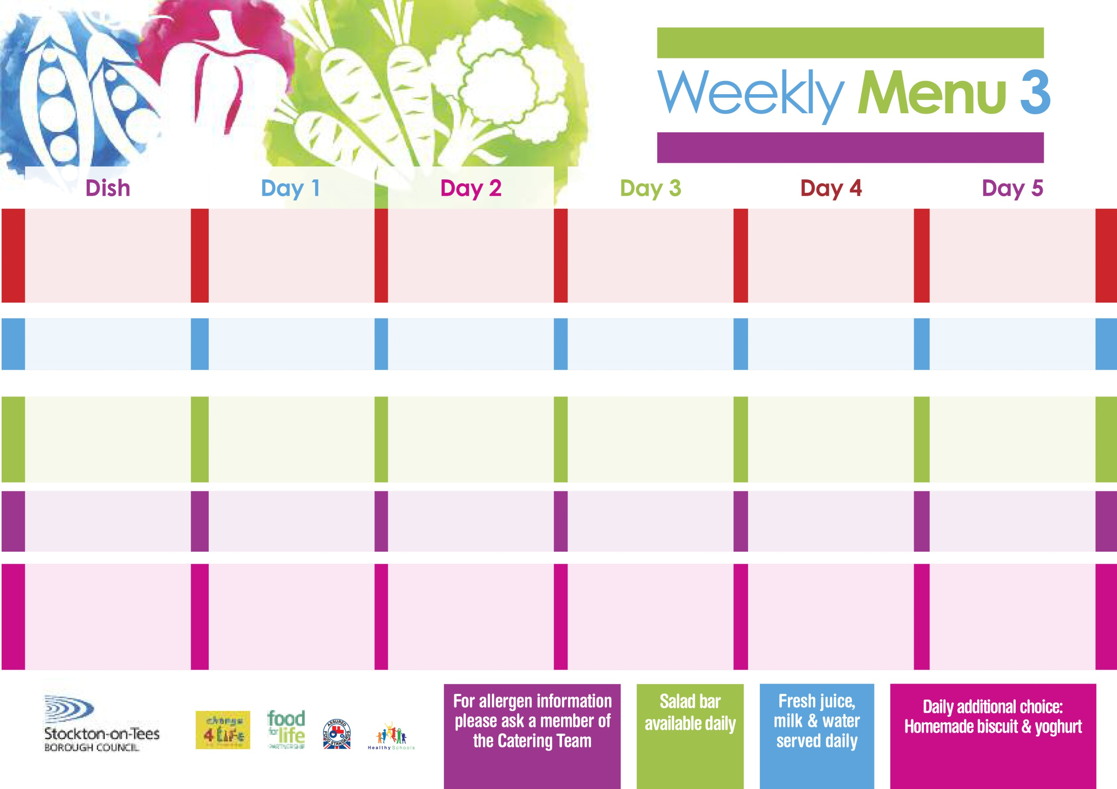

**15th January, 12th February & 18th March, 2024**

**Chicken Pie**

**Creamed Potatoes**

**Diced Carrots**

**Swede**

**Diced Quorn Pie (V)**

**Homemade Pizza**

**Baked Beans**

**Ham Sandwich**

**Baked Potato Wedges**

**Oaty Apple Crumble**

**with Custard Sauce**

**Cold Bar**

**Fresh Fruit Salad**

**Salmon & Sweet Potato Fishcake**

**Oven Baked Chips**

**Garden Peas**

**Baked Beans**

**Homemade Cheese &**

**Tomato Pizza** **(V)**

**Oven Baked Chips**

**Garden Peas**

**Baked Beans**

**Egg Mayo Sandwich (V)**

**Oven Baked Chips**

**Lemon Sponge**

**with Custard Sauce**

**Cold Bar**

**Fresh Fruit Bowl**

**Beef Burger in a Bun**

**Oven Roasted Potatoes**

**Baked Beans**

**Garden Peas**

**Quorn Burger in a Bun (V)**

**Jacket Potato filled with**

**Tuna, Cheese (V)**

**or Baked Beans (V)**

**Egg Mayo Sandwich (V)**

**Oven Roasted Potatoes**

**Feathered Sponge**

**with Custard Sauce**

**Cold Bar**

**Fresh Fruit Bowl**

**Penne Pasta in**

**Tomato Sauce (V)**

**Homemade Garlic Bread**

**Broccoli**

**Mixed Vegetables**

**Cheese & Onion Roll (V)**

**Baked Jacket Potatoes**

**Spaghetti Hoops**

**Tuna Sandwich**

**Baked Jacket Potatoes**

**Syrup Roly Poly**

**with Custard Sauce**

**Cold Bar**

**Fresh Fruit Salad**

**Pork & Carrot Meatballs**

**in Gravy**

**Baby Boiled Potatoes**

**Cauliflower**

**Green Beans**

**Quorn Meatballs in Gravy (V)**

**Fishcake**

**Baby Boiled Potatoes**

**Spaghetti Hoops**

**Cheese Sandwich (V)**

**Baby Boiled Potatoes**

**Marble Sponge**

**with Custard Sauce**

**Cold Bar**

**Fresh Fruit Bowl**

**Red Choice**

**Blue Choice**

**Green Choice**

**Cold Selection**

**Desserts**

**Wristband Primary School Menu**