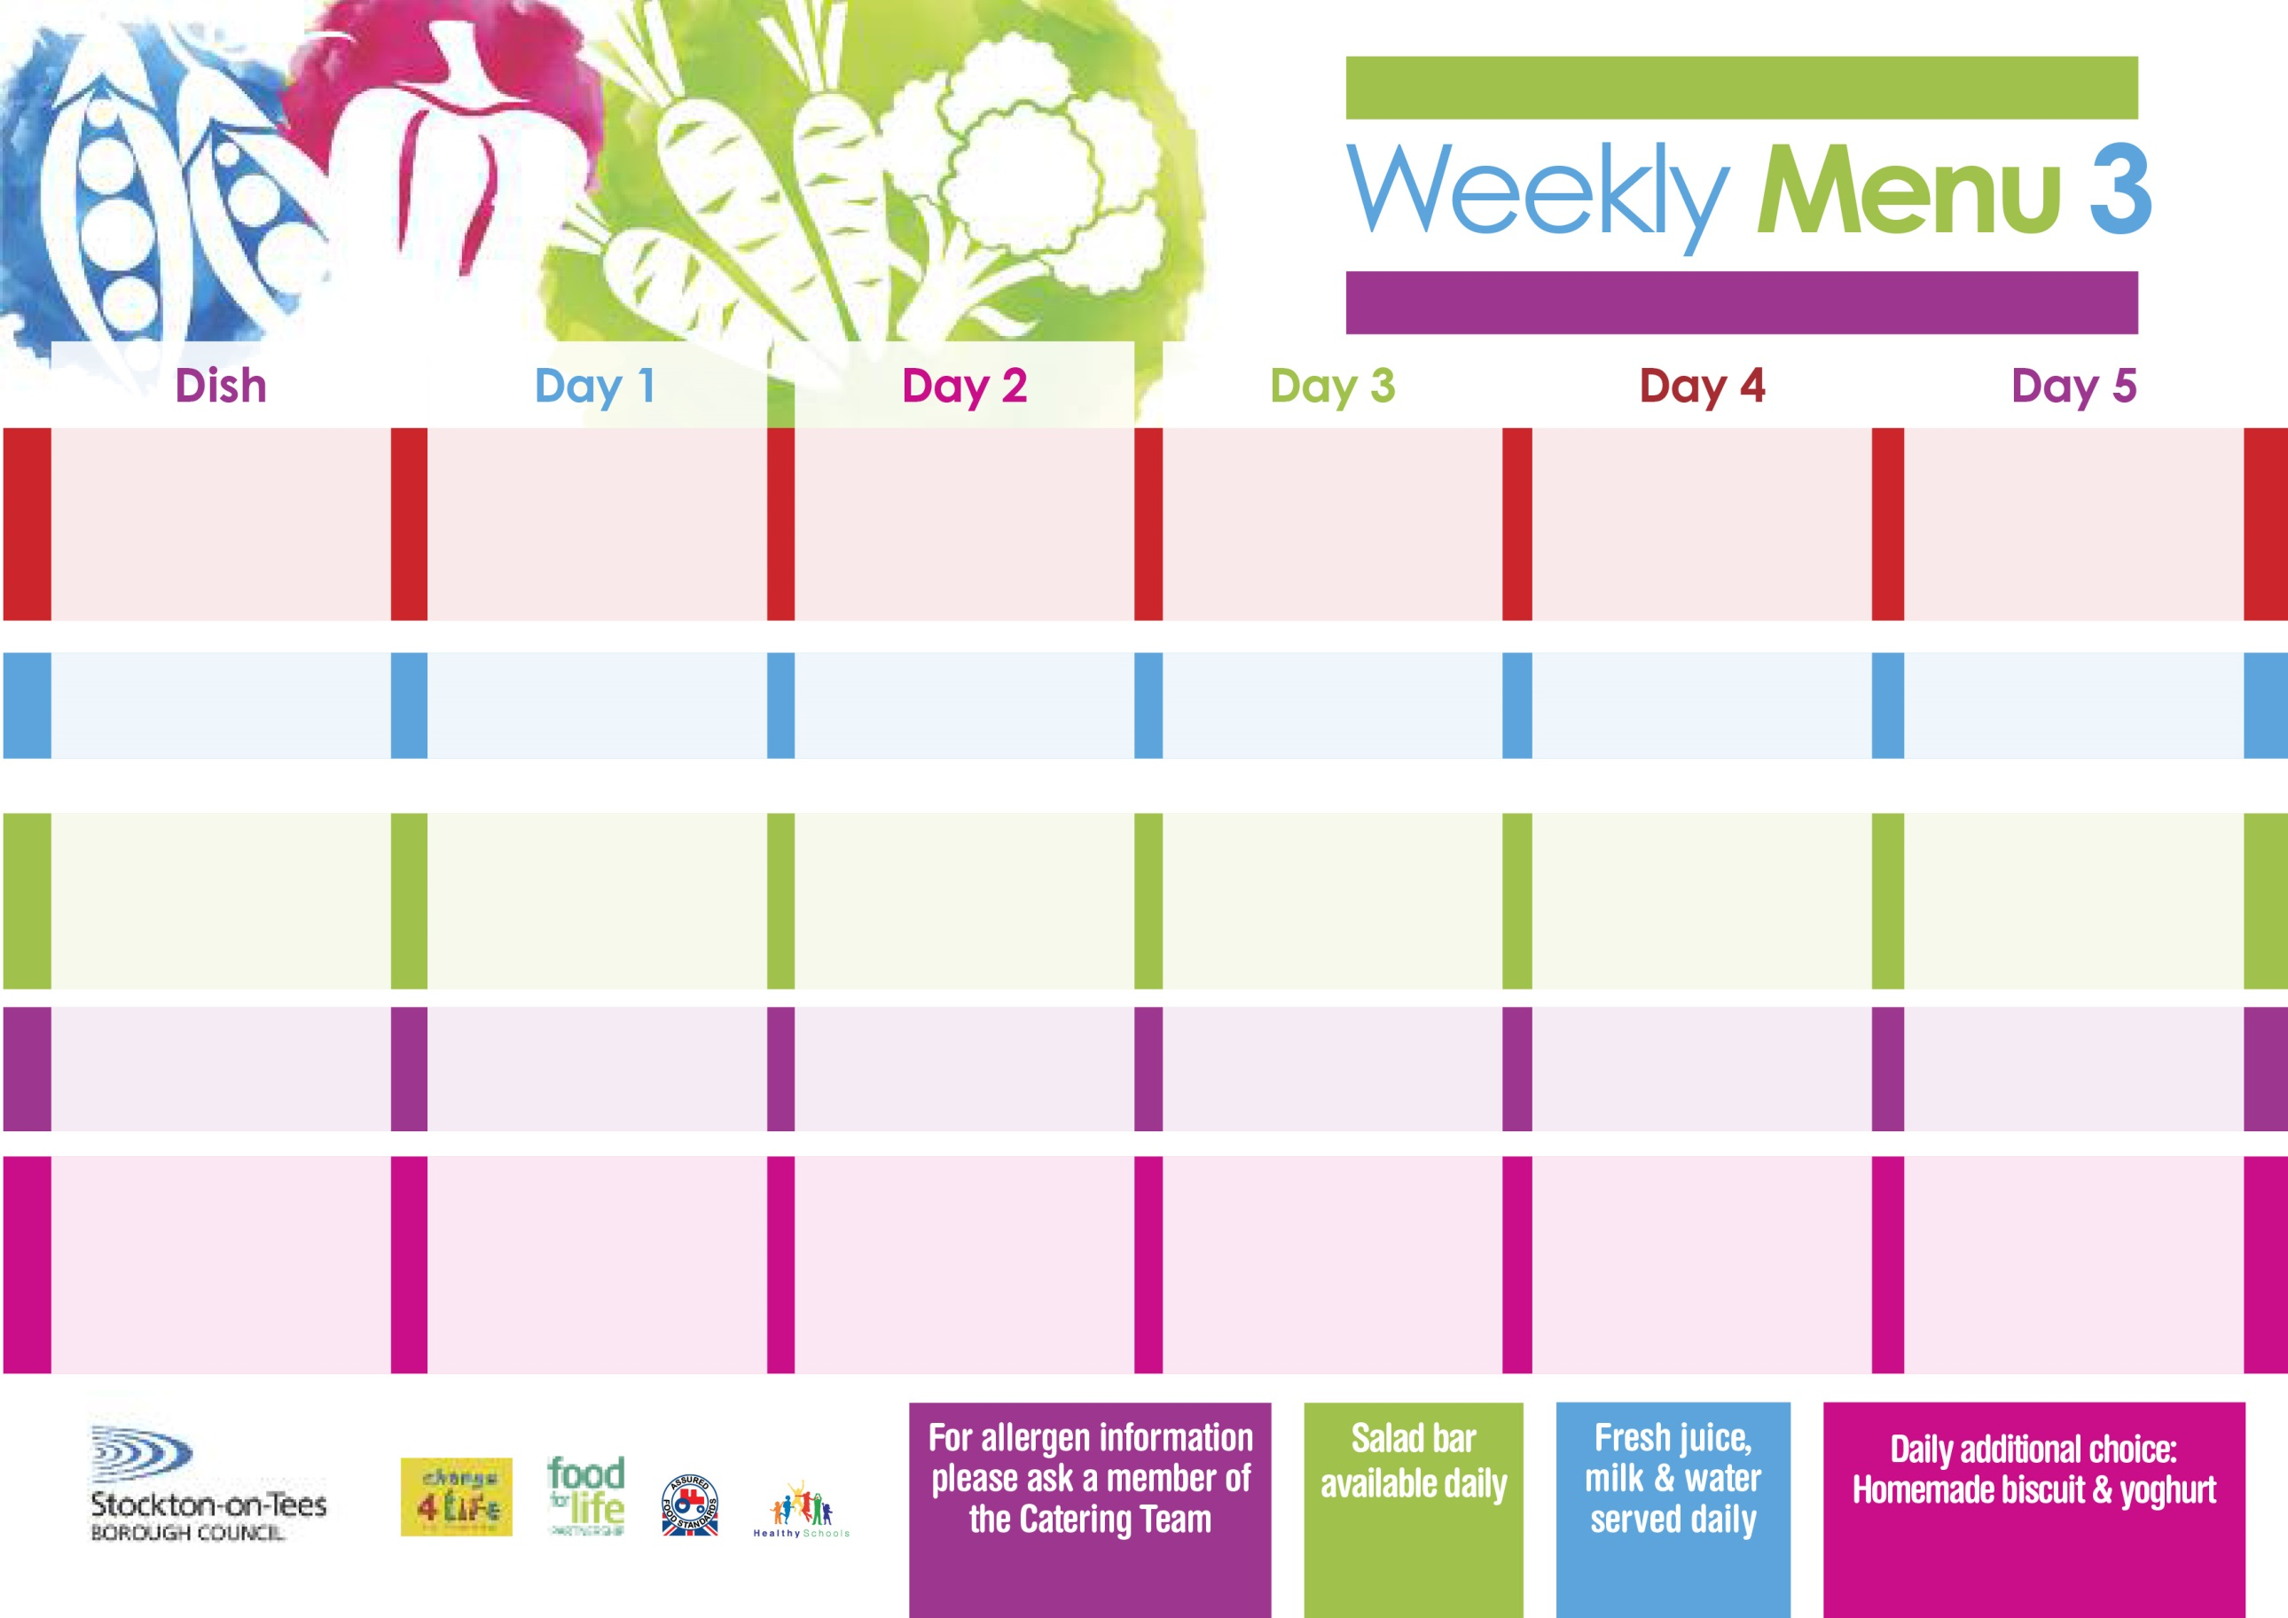

**16th September, 7th October, 4th & 25th November & 16th December, 2024 –**

**20th January & 10th February, 2025**

**Breaded Chicken Breast Fillet**

**Oven Roasted Potatoes**

**Garden Peas**

**Sweetcorn**

**Macaroni Cheese (V)**

**Homemade Herby Bread**

**Garden Peas**

**Sweetcorn**

**Tuna & Cucumber Sandwich**

**Oven Roasted Potatoes**

**Oaty Apple Crumble**

**with Custard Sauce**

**Cup Cake**

**Homemade Biscuit**

**Yoghurt**

**Homemade Pizza (V)**

**Oven Baked Chips**

**Garden Peas**

**Baked Beans**

**Quorn Dippers (V)**

**Oven Baked Chips**

**Garden Peas**

**Baked Beans**

**Egg Mayonnaise Sandwich (V)**

**Oven Baked Chips**

**Chocolate Chip Sponge**

**with Custard Sauce**

**Ice Cream**

**Homemade Biscuit**

**Fresh Fruit Bowl**

**Lasagne**

**Homemade Garlic Bread**

**Tossed Salad**

**Quorn Lasagne**

**(V)**

**Jacket Potato filled with**

**Tuna, Cheese (V)**

**or Baked Beans (V)**

**with Tossed Salad**

**Cheese Sandwich (V)**

**Baked Jacket Potatoes**

**Jam Roly Poly**

**with Custard Sauce**

**Jelly**

**Homemade Biscuit**

**Fresh Fruit Bowl**

**Pork & Carrot Meatballs with Pasta in a Tomato Sauce**

**Mixed Vegetables**

**Quorn Meatballs (V)**

**Sausage Roll**

**Baked Jacket Potatoes**

**Spaghetti Hoops**

**Tuna Mayonnaise Sandwich**

**Baked Jacket Potatoes**

**Cornflake Tart**

**with Custard Sauce**

**Iced Bun**

**Homemade Biscuit**

**Yoghurt**

**Cottage Pie**

**Diced Carrots**

**Broccoli**

**Baked Cheese Roll (V)**

**Oven Baked Potato Wedges**

**Spaghetti Hoops**

**Egg Mayonnaise Sandwich (V)**

**Oven Baked Potato Wedges**

**Syrup Sponge**

**with Custard Sauce**

**Chocolate Brownie**

**Homemade Biscuit**

**Fresh Fruit Bowl**

**Traditional**

**(RED)**

**VEGETARIAN**

**(GREEN)**

**Sandwich Selection**

(**Black**)

**Desserts**

**Primary School Menu**