Reviewed October 2024

## Prior’s Mill CE Primary School

## SEND Information Report



Headteacher – Mr R Linsley

SENCo – Mrs K McHale

SEND Governor – Mrs C Craggs

Contact: 01642 650426



Additional Services – Contact Information

**Special Educational Needs and Disability (SEND) Information, Advice & Support Service (SENDIASS)**

Telephone: 01642 527158

Email: [**SENDIASS@stockton.gov.uk**](mailto:parent.partnership@stockton.gov.uk)

**SEN & Engagement Service**

Address: SEN & Engagement Service,

Stockton Borough Council,

4th Floor,

Queensway House,

West Precinct,

Billingham,

TS23 2YQ

Telephone: 01642 527145

Email: [**sensection@stockton.gov.uk**](mailto:sensection@stockton.gov.uk)

**Stockton Parent Carer Forum**

<https://stocktonparentcarerforum.co.uk/>

**Telephone: 07985 245668**

**Email:** [**info@stocktonparentcarerforum.co.uk**](mailto:info@stocktonparentcarerforum.co.uk)

**Email**



School Core Offer

#### **Prior’s Mill Primary School’s Core Offer:**

Our Local Offer details information around the support and provision that parents and carers of pupils who have Special Educational Needs or a disability (SEND) can expect to receive, if their child attends Prior’s Mill CE Primary School.

[Stockton Local Offer](https://www.stocktoninformationdirectory.org/kb5/stockton/directory/localoffer.page?localofferchannel=0)

###### What do we offer at Prior’s Mill C.E. Primary School?

Prior’s Mill C.E. Primary School is an inclusive school, founded in the Christian faith, which embodies Christian values in its daily life by promoting, encouraging and celebrating the abilities of all within the school community through its:

* Inclusive ethos
* Broad and balanced curriculum for all pupils
* Systems for early identification of barriers to learning and participation.
* High expectations and suitable targets for all children.

At Prior’s Mill C.E. Primary School, ALL children matter. We are interested in the whole child, not just their academic progress. We are an inclusive school that looks to ensure the wellbeing of all children, this is catered for through our integrated curriculum and the professionalism of our teaching and support staff.

# School Core Offer

#### **Prior’s Mill Primary School’s Core Offer:**

###### Assessment for all children:

Continual assessment takes place for all children through marking and feedback, formative and summative assessment, questioning and day to day understanding of our children and their needs. Progress is carefully monitored within school, with each child moving from their own starting point. Teachers record significant data internally on a termly basis to enable them to identify children who are and are not making progress, which in turn allows us to identify whether we may consider that individual children may have additional needs, alongside a vast range of additional information from knowing and working with our children on a daily basis.

Assessments in each phase:

* Early Years – Prime and Core areas of learning
* Key Stage 1 - Reading, Writing, Phonics and Mathematics
* Key Stage 2 - Reading, Writing and Mathematics

Across school, we also monitor progress in social and emotional areas too as we believe that a child will flourish when their needs in all areas are being met.

**Complaints Procedure:**

For any formal complaints regarding SEND within school, please follow the Schools Complaints Procedure.

# School Core Offer

### SEND Support at Prior’s Mill

When a pupil is identified as having SEND, Prior’s Mill Primary School will take action to remove

barriers to learning and put effective special educational provision in place.

This SEND support will take the form of a four-part cycle – assess, plan, do, review - through which earlier actions are revisited, refined and revised.

###### SEN support in schools:

A child or young person has SEND if they have a learning difficulty or disability which calls for

special educational provision to be made for him or her. The main areas of SEND are:

* Cognition and Learning
* Communication and Interaction
* Social, Emotional and Mental Health
* Sensory and/or Physical needs

Upon registering a child as SEND in our school, we will assess which of the four categories above their

needs primarily fit into. We understand that SEND is not so easily categorised and it is likely that

children will have needs in more than one area, which will have an impact on each other.

A child of compulsory school age or a young person has a learning difficulty or disability if he or she: has a significantly greater difficulty in learning than the majority of others of the same age, or has a disability which prevents or hinders him or her from making use of facilities of a kind generally provided for others of the same age in mainstream schools. For children aged two or more, special educational provision is educational or training provision that is additional to or different from that made generally for other children or young people of the same age by mainstream schools, maintained nursery schools, or by relevant early years providers.

* Children in all three Key Stages are continually assessed through marking work, discussion, testing and questioning and their progress is carefully monitored. Teachers record data termly to enable them to identify children with Special Educational Needs and monitor progress
* If SEND are identified, a meeting is set up with parents to

discuss assessments and SEND plans.

* Pupils are very much encouraged to take part in setting targets for their SEND plan – these are noted on the second sheet of the SEND plan. Pupils are invited to review meetings and their opinions taken into account when setting the new targets.
* In terms of formal assessment, SEND children may require additional access arrangements. School will apply for these as and when necessary.
* The SENCo attends regular meetings and training to remain up to date with current information and good practice. This information is then disseminated to staff as appropriate.
* Each child with SEND, whether they access SEN Support or have an Education Health Care Plan, will have a SEND plan. This will identify the needs of the child, targets based on assessment and interventions and strategies to support learning. All relevant staff who come into contact with the child will have access to the SEND plan. Targets and assessment are discussed with parents and the child at the termly SEND review.
* Transition meetings are held between the child’s current and new teacher at the beginning of each academic

year where information is shared and discussed.

* Parents are consulted when a child is placed on



the SEND Register and invited to attend

termly review meetings. Parents thoughts and contributions are sought and are highly valued.

Parents thoughts are noted on the review section

of the SEND plan and a copy of the completed outgoing plan and new plan are given at the meeting

* Parents are always invited to meet with teachers from outside agencies who come into school to work with children.
* Parents/Carers can find additional information about SEND in schools in our SEND Policy, the Local Authority offer and in the Special Educational Needs and Disability Code of Practice 2014.

Once the SEND plan has been agreed by staff,

* children and parents, actions are put into place as detailed on the individual plan. Teaching and support

staff work together to ensure that the targets are addressed in the weekly planning and an intervention timetable put into place accordingly.

* Feedback on progress is also given both verbally and through the school’s marking and feedback systems.
* The progress and evidence gathered over the term is used as a focus for the SEND review meeting

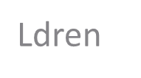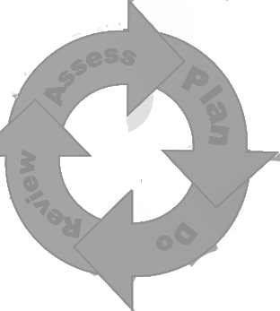

### Prior’s Mill SEND offer Assessment for SEND children:

**Specialist SEND Assessment:**

Once a child had been identified as needing SEND support, the teacher, parents and child will carry out an assessment, monitoring and analysis of the child’s needs. Where the child’s progress continues to be less than expected, the SENCo may make referrals to specialist SEND services for specialist assessment. Parents are always consulted and their consent requested.

**Educational Psychologist:**

A referral to the Educational Psychologist (EP) may be made should the school require more specialist assessment. The EP will observe the child, consult with teachers and parents and carry out individual assessments. Formal written feedback will be required with recommendations for school to act upon.

**CAMHS (Child and Adolescent Mental Health Service):**

If assessment by CAMHS is required to gain support with complex mental health concerns, a referral can be made through the through your child’s GP or directly from school



### Prior’s Mill SEND offer Assessment for SEND children:

### Speech and Language:

### When children have communication and interaction difficulties, a referral to Speech and Language can be made. A child does not have to be on our SEND register to access support from Speech and Language.

### ABC Counselling:

### If a child requires emotional support, a referral to ABC Counselling can be made. They offer play therapy sessions to children experiencing a range of difficulties, including:

### Bereavement/grief

### Attachment difficulties

### Pre and post adoption support

### Transition

### Anxiety

### <http://abccounsellingservices.com/>

### Alliance Psychology:

### For a number of years, we have worked with Alliance Psychology in order to provide additional emotional support to children across school. They support children and families with mild to moderate mental health/anxiety/behavioural concerns.

### <https://www.alliancepsychology.com/>

### Children do not have to be on the SEN register in school to access the emotional support services.

**SEND Support**

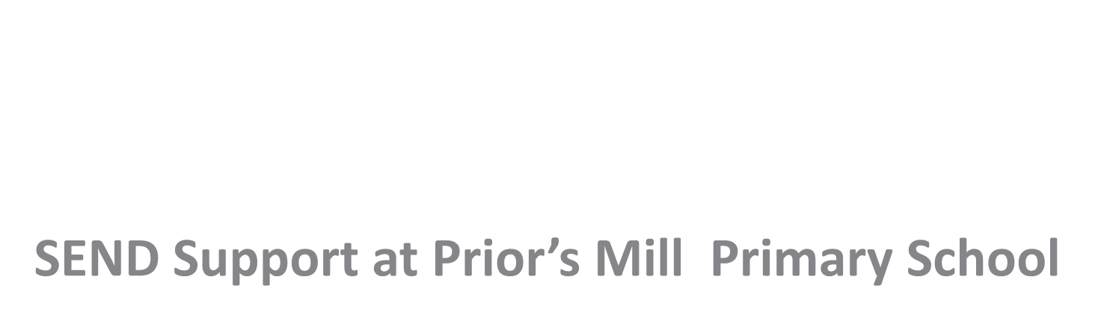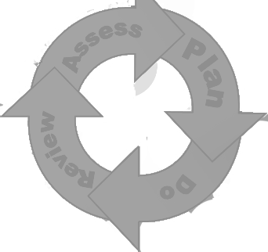

Our aim is that children with additional needs will be able to fill their full potential in all aspects of their leaning, social and personal development. We strive to ensure that all children are able to access the Early Years and Primary Curriculum in an inclusive and supportive environment. We provide a variety of teaching styles, which are tailored to match the individual learning styles of children and differentiate all tasks and activities accordingly. Parents and carers are involved in the target setting and review process.



**Education, Health & Care Plan**

**(EHCP)**

**From the SEND Code of Practice:**

While the majority of children with additional needs will have these needs met within mainstream settings and

schools, some children may require an EHC needs assessment in order for the local authority to decide whether it

is necessary for them to make appropriate provision

‘The purpose of an EHC plan is to make special educational provision to meet the special educational needs of the

Child or young person, to secure the best possible outcomes for them across education, health and social care and,

as they get older, prepare them for adulthood.’

**At Prior’s Mill:**

At our school, when a child has an EHCP, we ensure that all aspects of the plan are implemented, monitored

and reviewed so our children have the best provision to suit their needs. This may include:

* Intervention time
* Access to external professionals
* Bespoke work on targets from the EHCP

[SEND Code of Practice 2015](https://assets.publishing.service.gov.uk/government/uploads/system/uploads/attachment_data/file/398815/SEND_Code_of_Practice_January_2015.pdf)

**How is different SEND provision delivered in school?**

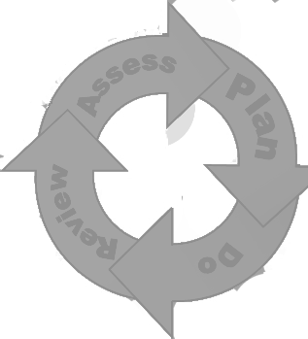

Our curriculum is differentiated to meet the needs of all children and has been planned to ensure the additional needs of the children are met. Adaptations are made to teaching and learning styles to suit all children. Furthermore, specific resources are purchased across the curriculum to meet the needs of all groups. Staff development is provided through a range of professionals, to ensure teachers and support staff, maintain a high level of knowledge and understanding. Outside agencies also work closely with staff to undertake regular assessment and offer specialist advice and support to staff. They also work directly with children.

The SENCO and Senior Team monitor the provision of the curriculum provided and offer support and advice to staff. In addition, lessons are observed and work is sampled. Meetings are held regularly between staff to discuss the progress made by the SEND children in each class.

###### School visits:

School visits are planned to meet the needs of all children including those with SEND. All trips across school are organised in small groups of children to ensure that the visit matches the needs of all the children with many opportunities for discussion.

###### Extra-curricular activities:

We offer a range of extra-curricular activities across school and all children are welcome to attend. Any reasonable adjustments required in order for individual children to attend the activity can be made.

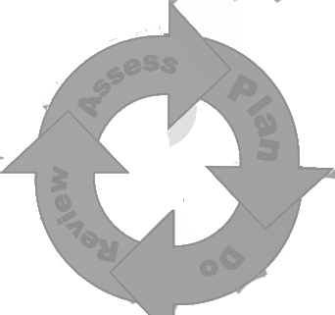

### REVIEW

SEND Plans are continually kept under review and their success is evaluated with parents, carers and children at a termly review meeting. Parents’ views on their child’s progress are sought as part of this process each term. Pupils are part of the review and are involve in setting and evaluating targets.

EHCPs will be reviewed at least annually to discuss progress made towards objectives and to consider the educational provision outlined in the EHCP. These are arranged by school and involve all personnel concerned with the child: parents, LA representatives, teachers, support assistants, support services with ongoing involvement and the pupil themselves.

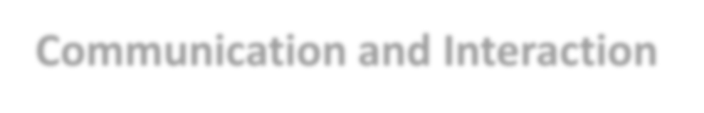

##### Communication and Interaction

Adaptations to the curriculum and learning environment can be made to suit the individual needs of children with

Communication and Interaction Difficulties. These may include:

•Access to small group and/or individualised interventions

to develop skills in communication, interaction, emotional awareness, self

care and flexible thinking,

•Enhanced access to visual approaches,

•Access to technology,

•Explicit teaching of generalising skills from one context to another,

•Social stories developed to support children in different social situations,

•Structured and supported indoor and outdoor playtimes,

•Access to an individual work area within the classroom,

•Alternative curriculum opportunities,

•Visual timetables to support children who benefit from structure and routine,

* Transition planning.

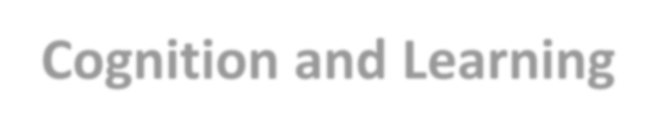

### Cognition and Learning

Adaptations to the curriculum and learning environment can be made to suit the individual needs of children with Cognition and Learning Difficulties. These may include:

* Regular focussed interventions,
* ICT interventions – Lexia,
* Access to small group work,
* Practical aids,
* Phonic development programmes,
* Flexible groupings,
* Adaptations to assessments including access arrangements,
* Adaptation to the curriculum,
* Frequent repetition and enforcement of skills and knowledge.



##### Social, Emotional and Mental

**Health Difficulties**

Adaptations to the curriculum and learning environment can be made to suit the individual needs of children with Social, Emotional and Mental Health Difficulties. These may include:

•Access to an individual work area within the classroom,

•An individualised rewards system,

•Alternative curriculum opportunities,

•Opportunities to develop social skills,

•Visual timetables to support children who benefit from structure and routine,

* Transition planning for moving year groups and across Key Stages,
* Access to social and emotional support – ABC Counselling & Alliance Psychology.



### Sensory and/or Physical Needs

Adaptations to the curriculum and learning environment can be made to suit the individual needs of children with sensory and/or physical needs. These may include:

* Physical aids to support access such as a wheelchairs, walking frames, specialist chairs, hearing aids, large print materials, sound field system,
* Access to a specialist teacher/LSA for the hearing/visually impaired,
* Concrete apparatus available to support learning,
* Access to support for personal care,
* Therapy programmes delivered in school, designed by specialists such as Occupational

Therapists, Physiotherapists and Speech and Language Therapy,

* Focused interventions including physio/occupational therapy exercises,
* Adapted curriculum to enable full access. This may include alternative recording devices or a modified PE or music curriculum for children with physical and sensory needs.

