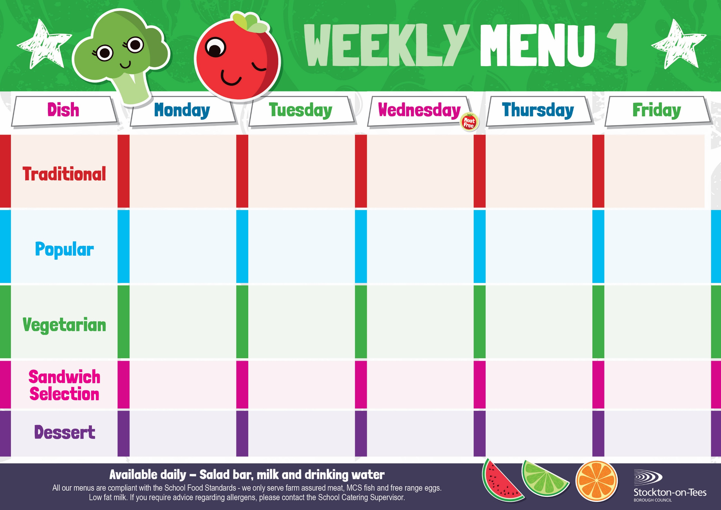

Cheese

Potato Wedges

Tuna Mayonnaise

Baked Jacket Potato

Baked Cheese & Onion Roll

Baked Jacket Potato

Spaghetti Hoops

Cheese Omelette Roasted Potatoes

Baked Beans

Sweetcorn

Fish Fillet Fingers

Potato Wedges

Spaghetti Hoops

Egg Mayonnaise

Roasted Potatoes

**Weeks beginning** **28th April, 19th May, 26th June & 7th July, 2025**

Creamy Rice Pudding &

Jam Sauce

Ice Cream

Homemade Biscuit &

Fresh Fruit

Syrup Roly Poly &

Custard Sauce

Iced Bun

Homemade Biscuit &

Fresh Fruit

Marble Sponge &

Custard Sauce

Fruity Cookie

Homemade Biscuit &

Fresh Fruit

Apple Crumble &

Custard Sauce

Fruity Muffin

Homemade Biscuit &

Fresh Fruit

Jam Sponge &

Custard Sauce

Jelly Whirl

Homemade Biscuit &

Fresh Fruit

Roast Ham

Oven Baked Chips

Penne Pasta in Tomato Sauce

Homemade Garlic Bread

Garden Peas

Tuna Mayonnaise

Baby Boiled Potato

Baked Jacket Potato with Tuna

Harry Ramsden

Fish Fillet

Oven Baked Chips

Garden Peas &

Baked Beans

Quorn Casserole & Dumplings

Creamed Potatoes

Mixed Vegetables

Cauliflower

Baked Jacket Potato with Cheese or Baked Beans

Baked Sausages in Gravy

Baby Boiled Potatoes

Carrots & Green Beans

Roast Beef with Yorkshire Pudding

Creamed Potatoes

Broccoli & Swede

Homemade Pizza

Roasted Potatoes

Baked Beans

Sweetcorn

Chicken Casserole & Dumplings

Creamed Potatoes

Mixed Vegetables

Cauliflower