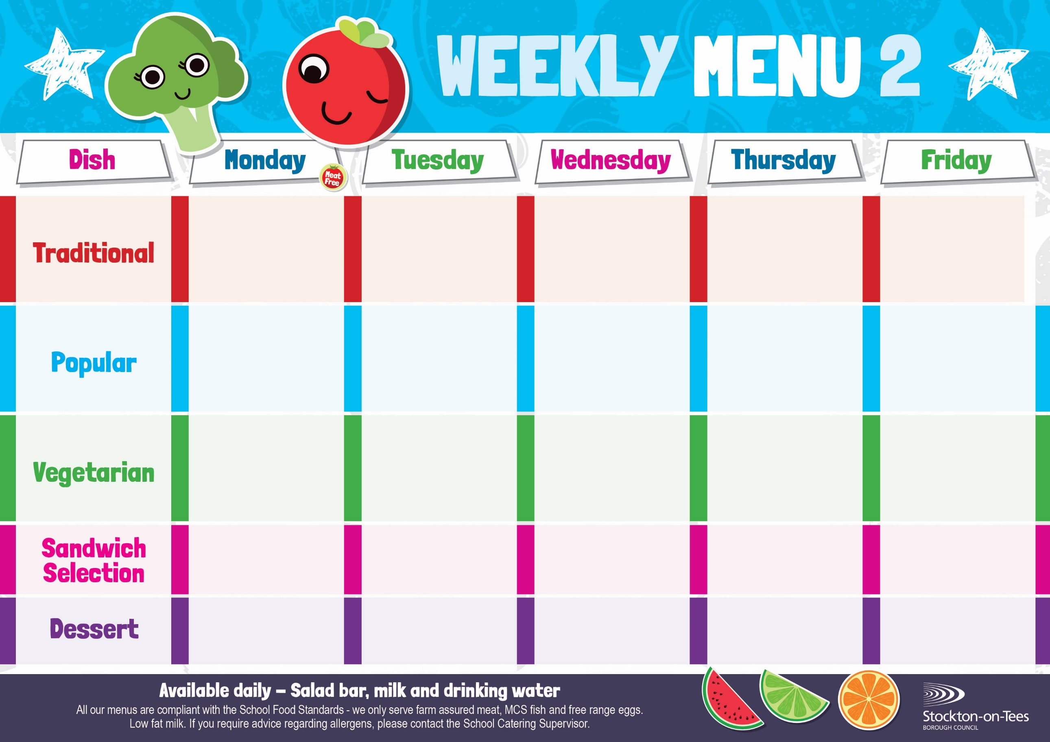

Roast Ham

Baked Jacket Potato

Cheese Quiche

Oven Baked Chips

Garden Peas

Baked Beans

Macaroni Cheese

Homemade Herby Bread

Garden Peas

Vegan Meatballs in Tomato Sauce with Pasta

Sweetcorn

Quorn Bolognaise

Homemade Garlic Bread

Mixed Vegetables

Diced Quorn Pie

Creamed Potatoes

Green Beans & Swede

Fish Stars

Baked Jacket Potato

Spaghetti Hoops

Sausage Roll

Potato Wedges Baked Beans

Mini Cheese Slice

Baked Jacket Potato

Sweetcorn

**Weeks beginning** **5th May, 2nd June, 23rd June & 14th July, 2025**

Vanilla Sponge &

Custard Sauce

Jelly

Homemade Biscuit &

Fresh Fruit

Creamy Rice Pudding &

Jam Sauce

Ice Cream

Homemade Biscuit &

Fresh Fruit

Festival Shortcake & Custard Sauce

Cup Cake

Homemade Biscuit &

Fresh Fruit

Eve’s Pudding &

Custard Sauce

Choc Chip Cookie

Homemade Biscuit &

Fresh Fruit

Fish Goujons

Oven Baked Chips

Garden Peas

Baked Beans

Spaghetti Bolognaise

Homemade Garlic Bread

Mixed Vegetables

Chocolate Crunch &

Custard Sauce

Decorated Iced Sponge

Homemade Biscuit &

Fresh Fruit

Tuna Mayonnaise

Oven Baked Chips

Tuna Mayonnaise

Potato Wedges

Cheese

Baked Jacket Potato

App

Egg Mayonnaise

Roasted Potatoes

Homemade Pizza

Roasted Potatoes

Garden Peas

Spaghetti Hoops

Pork & Carrot Meatballs in Tomato Sauce with Pasta

Sweetcorn

Chicken Pie

Creamed Potatoes

Green Beans

Swede