Early Years  Prior’s Mill – Writing long term plan 25/26 |  | Year One | Year Two | Year Three | Year Four | Year Five | Year Six
Follow the Little Wandle scheme throughout the year – focus on phonics and mark making in the areas.  Drawing club – fine motor skills, mark making, vocabulary and promoting a love of reading and writing.  -To write recognisable letters, most of which are correctly formed  -To write labels, lists and phrases  -To begin to write between/on lines  -To write simple sentences  -To form lower and upper-case letters correctly  -To use capital letters, full stops and finger spaces in a sentence  -To use connectives to join ideas together when writing  -To write a simple recount and a short narrative  -To use core muscle strength to achieve a good posture when sitting at a table or sitting on the floor.  -Learn new vocabulary  -Use new vocabulary throughout the day  -Articulate their ideas and thoughts in well-formed sentences  -Connect one idea or action to another using a range of connectives  Spelling  -spell words by identifying the sounds and then writing the sound with the letter/s.  -write some common irregular words | Autumn One | Books – see separate Reading spine below.  Simple sentence construction based on the ELG to consolidate prior learning of phonics and embed independent writing. | Book – Meerkat Mail  Place Value of Grammar- 6 week block | Book – Leon & the place between  Place Value of Grammar- 6 week block | Book – The Creakers  Place Value of Grammar- 6 week block | Book – Percy Jackson & The Lightning Thief  Place Value of Grammar- 6 week block | Book – The Boy in The Tower  Narrative- Setting description  Non-narrative- Instructions (choice of layout/form)  Non-Narrative- Biography
 | Autumn Two | Books – see separate Reading spine.  Simple sentence construction based on the ELG to consolidate prior learning of phonics and embed independent writing.  Focus on transcription, composition of sentences and sequence to short narratives. | Book – Bog Baby  Non-narrative- Instructions (how to look after Bog Baby)  Narrative- Character Profile | Book – Charlie and the Chocolate Factory  Poetry-Acrostic  Narrative- Character profile - Charlie etc.  Non-narrative- Persuasion (poster for a new chocolate/sweet) | Book – The Witches  Poetry- Kennings  Narrative- Story (could be about being turned into an animal)  Non-narrative- Recount-Letter | Book – Boy in the striped Pyjamas  Narrative- Diary Entry  Non-Narrative- Persuasion (choice of form letter, speech, poster, leaflet on evacuation of children)  Non-narrative- Eyewitness Account (two different viewpoint of the same event) | Book – War Horse  Non-narrative- Story from the POV of an animal or inanimate object  Non-narrative- non-chronological report (children’s choice of context and form)
 | Spring One | Books – see separate Reading spine.  Phonic Focus – more independent writing.  Start to introduce genres | Book -Alexander and The Horrible, No Good, Very Bad Day  Narrative- Story Writing  Non-narrative- Recount (imaginary) | Book -The Iron Man  Non-narrative – instructions  Narrative – story writing (imaginary world) | Book – Butterfly Lion  Narrative- Story set in another country  Non-narrative- non-chronological report  Non-narrative- Advert (for the circus/animal show/holiday in a hot country etc.) | Book -The Lion, The Witch and The Wardrobe  Narrative- Portal story  Non-narrative- non-chronological report (imaginary creature) | Book – Wonder  Narrative-Character description (Doesn’t have to be an existing character)  Non-Narrative- Discussion  Non-Narrative- Diary Entry (from 2 characters’ contrasting viewpoints of the same event)
 | Spring Two | Books – Where the Wild Things Are  Begin to introduce the writing process and genres.  Description | Book – Voices in the park  Poetry-Weather poems  Narrative- Character profile  Non-narrative- Report on an animal | Book -Charlotte’s Web  Non-Narrative- Recount-Letter  Non-narrative- Non-chronological report (based on Topic) | Book – Stuart Little  Narrative- Character Description  Non-narrative- Recount- Diary (imaginary) | Book – Kensuke’s Kingdom  Narrative- Character Description/Setting Description  Non-Narrative- Explanation- survival guide (children to choose form)  Non-narrative- Discussion- children’s choice | Book - Holes  Non-narrative- Travel brochure (choice of form)  Non-narrative- collection of evidence against a boy at Camp Green Lake- children’s free choice e.g. witness’ statements, police interviews, personal emails/text messages, social media  Narrative- Non-linear story  Non-Narrative- Courtroom Argument
 | Summer One | Books – Traditional stories  Begin to introduce the writing process and genres.  Retell a story  Instructions  Postcard | Book – The Bear and the Piano  Narrative- Story  Non-narrative- Diary entry (imaginary) | Book – The Diary of a Killer Cat  Narrative-Character profiles  Non-narrative- Diary entry | Book – The Last Bear  Narrative-Description – character, object or setting  Non-narrative- Explanation text (global warming) | Book - A Series of Unfortunate Events  Narrative- Diary  Non-narrative- Newspaper report (choice of form e.g., tabloid, broadsheet, live news feed etc.)
 | Summer Two | Books – Paddington  Recount  Story writing | Book - Vlad and the Great Fire of London  Narrative- Story writing  Non-narrative- Recount (real event) | Book – Bill’s New Frock  Narrative-Story Writing  Non-narrative- Recount of a real event | Book – Max and the Millions  Narrative- story  Non-narrative- Instructions | Book – The Giant’s Necklace  Narrative- Ghost Story  Poetry – Haiku (Summer themed) | Book – Skellig  Skellig  Narrative- Story  Non-narrative- Newspaper report (children’s choice of form)  Poetry- The Highwayman

 | Autumn 1  Phonic Focus | Autumn 2  Phonic Focus | Spring 1  Phonic Focus – more independent writing | Spring 2  Begin to introduce the writing process | Summer 1  Begin to introduce the writing process | Summer 2  Begin to introduce the writing process
Year 1 | 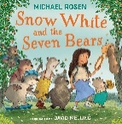  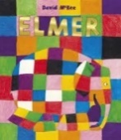  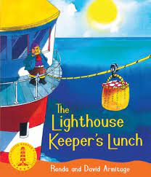  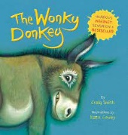  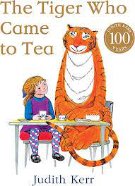  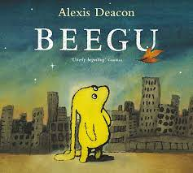 | 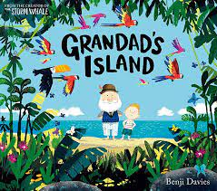  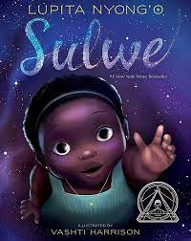  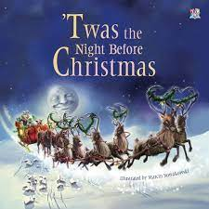  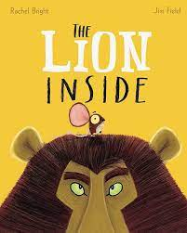  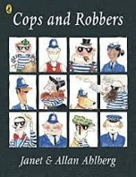  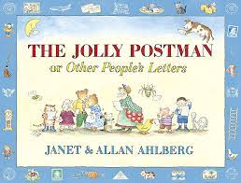 | 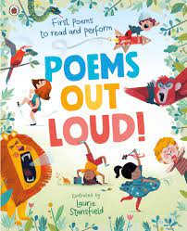  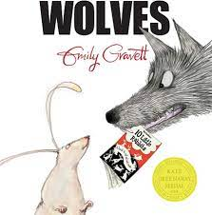  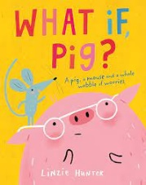  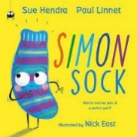  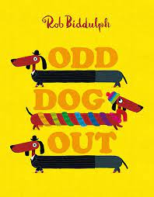  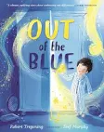 | 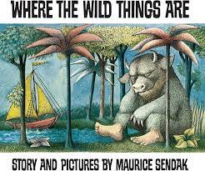  - Descriptions  - Riddle me this | 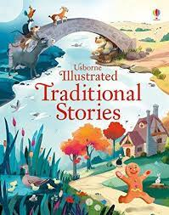  - Retell a story  - Instructions | 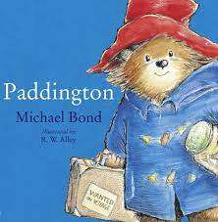  - Recount/Postcard  - Story writing

