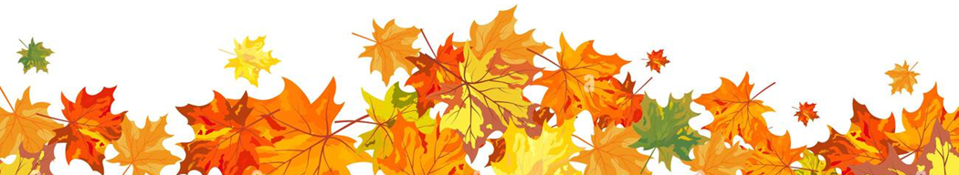
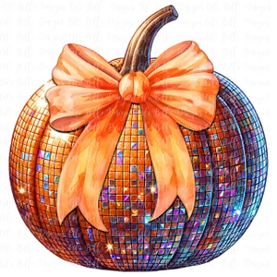
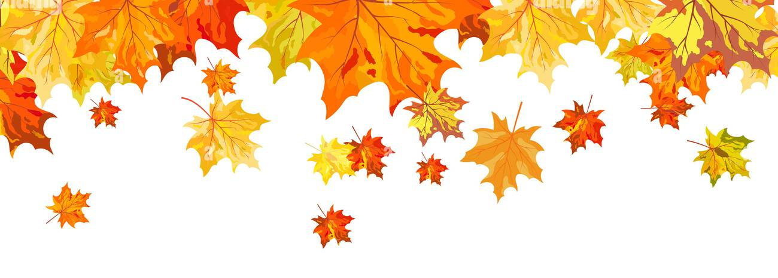
Dear Parents/Carers
We are delighted to invite your child to our School Disco for EYFS pupils, this will be held in KS2 Bede Hall on Thursday 23rd October from 1.30pm until 2.30pm.
The cost per child is £3.50 and this will include a drink, crisps, sweets and the disco.
Please make your payment via the Compass and inform the school office if your child has any
food allergies.
The closing date will be Friday 17th October.
Members of the teaching staff, as well as SPA Committee members, will be supervising the event. Pupils will need to be collected as normal at 3pm.
Children are welcome to attend school in non-uniform / party clothes ready for the disco.
All funds raised by SPA are used to enhance provision for children in school, we hope that your son/ daughter will be able to come along and enjoy the fun.
If any parents wish to help at the disco please contact the school office where a member of SPA will return.
your call.
Thank you.
SPA Committee
SPA EYFS Autumn Disco
Thursday 23rd October 2025
1.30pm-2.30pm

