
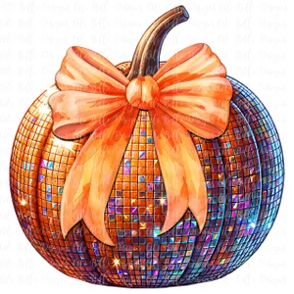

Dear Parents/Carers
We are delighted to invite your child to our School Disco for year 5 and 6 pupils, this will be held in KS2 Bede Hall on Thursday 23rd October from 5.15pm until 6.15pm.
The cost per child is £3.50 and this will include a drink, crisps, sweets and the disco.
Please make your payment via the Compass and inform the school office if your child has any
food allergies.
The closing date will be Friday 17th October.
Members of the teaching staff, as well as SPA Committee members, will be supervising the event.
Children can return to school at 5.15pm in their non-uniform / party clothes. Pupils will need to be collected by an adult from the KS2 playground at 6.15pm.
Please note pupils are not permitted to bring mobile phones, make-up or money. Please ensure your child is wearing sensible footwear (no heels) and is not wearing fancy dress.
All funds raised by SPA are used to enhance provision for children in school, we hope that your son/ daughter will be able to come along and enjoy the fun.
If any parents wish to help at the disco please contact the school office where a member of SPA will return.
your call.
Thank you.
SPA Committee
SPA Year 5 & 6 Autumn Disco
Thursday 23rd October 2025
5.15pm-6.15pm

